**Lab 2**

**Diagram:**

Before Simulation,

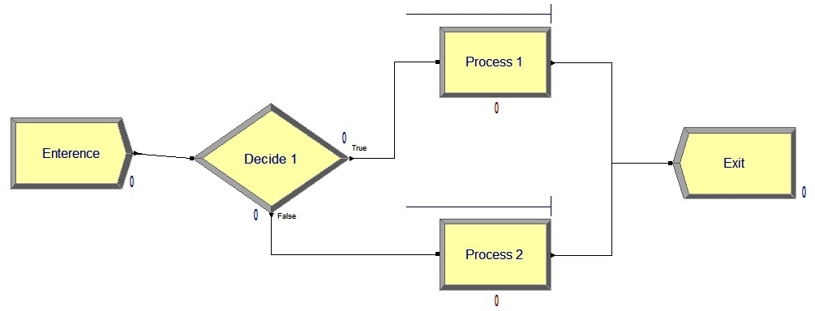

After Simulation,

